SELECT name, release_date FROM Games;
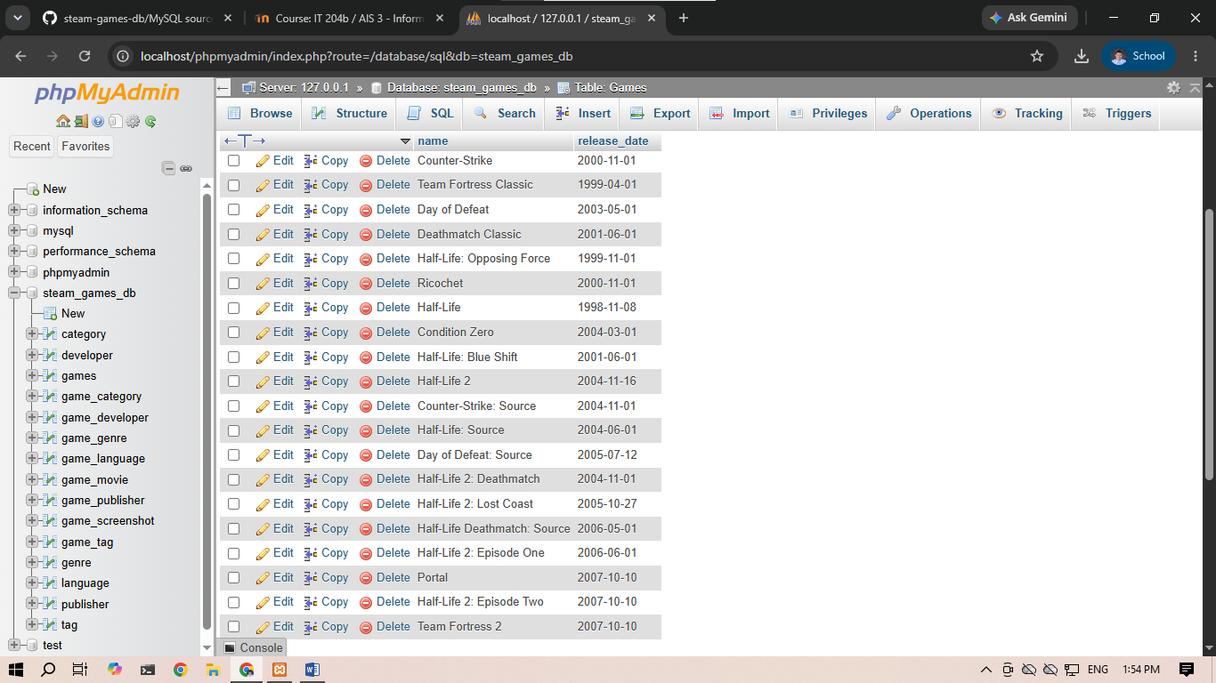
SELECT appID, peak_ccu FROM Games;
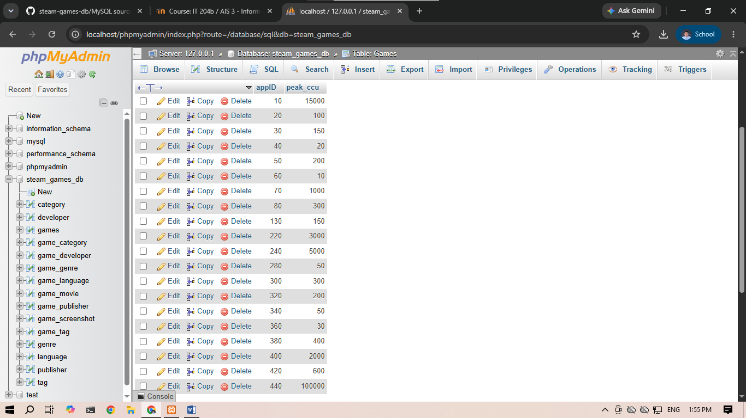

SELECT * FROM Games;
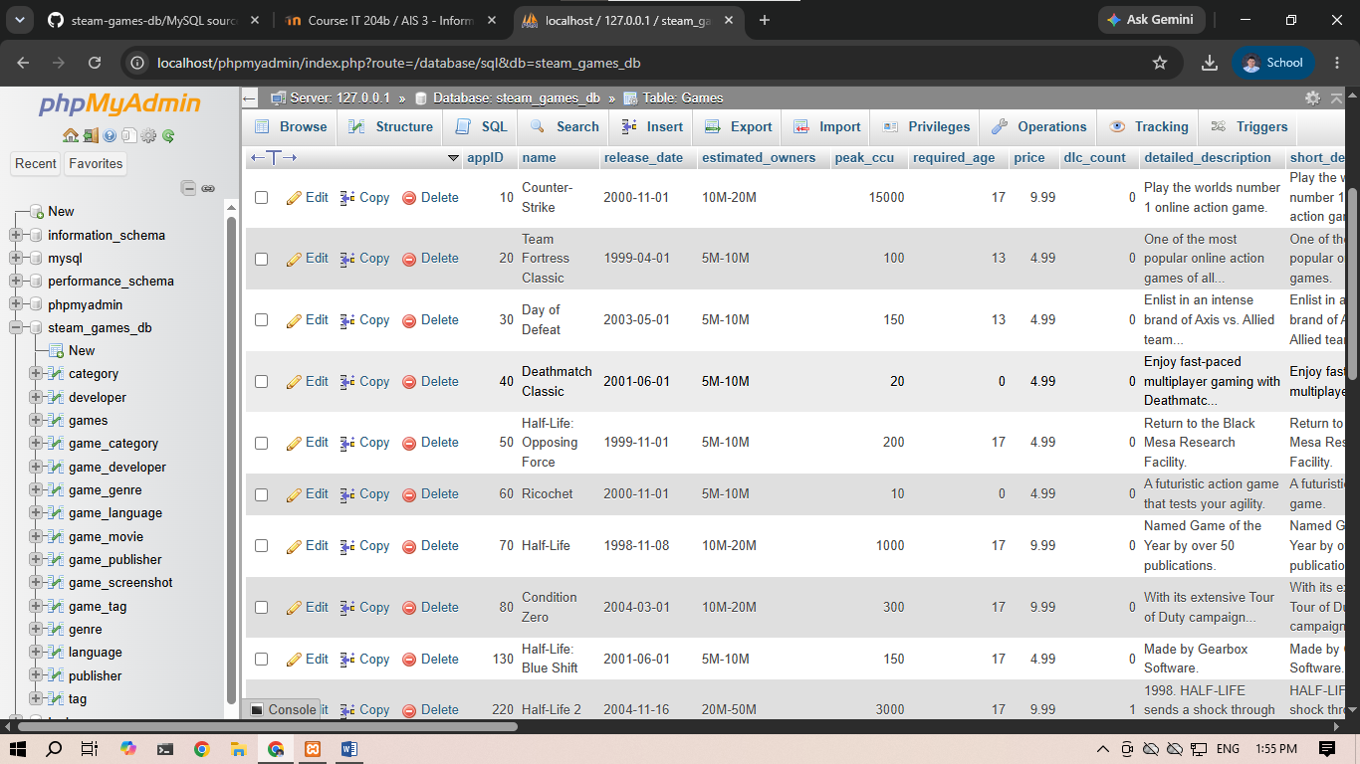
SELECT * FROM Developer;
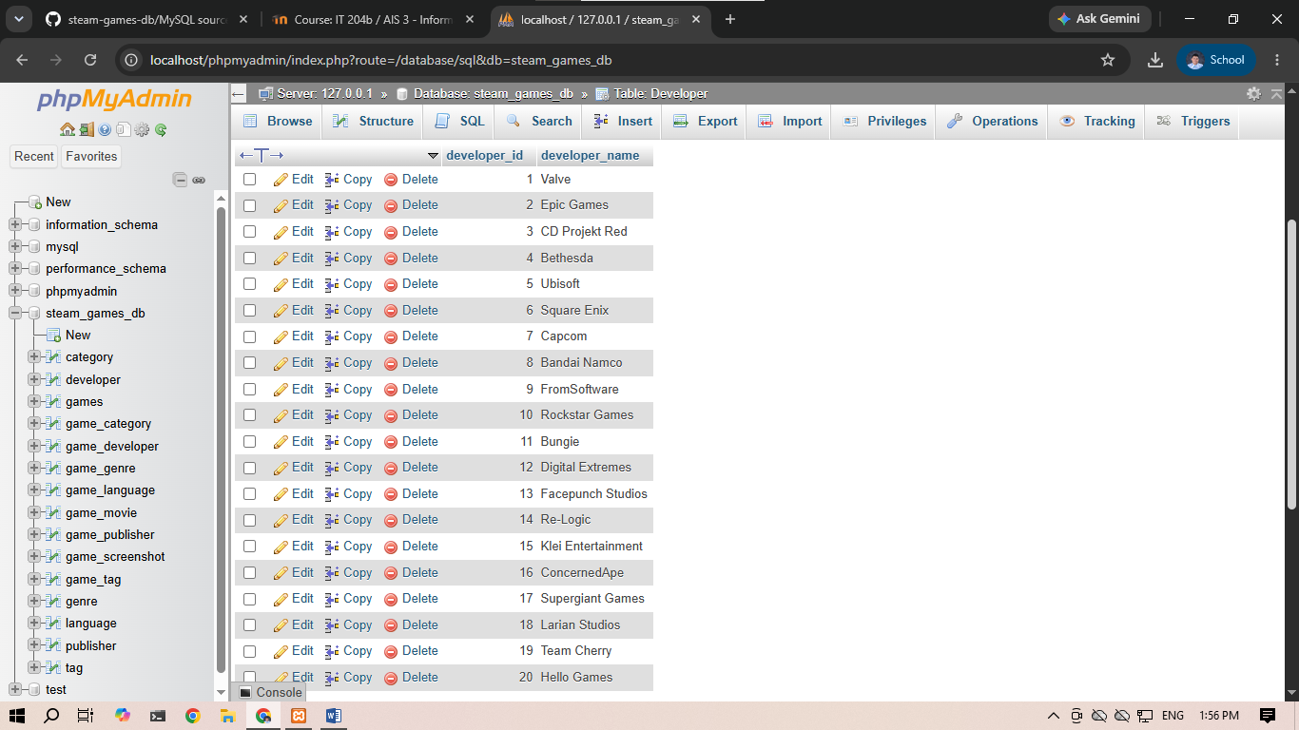

SELECT CONCAT(name, ' (ID: ', appID, ')') AS Game_Title FROM Games;
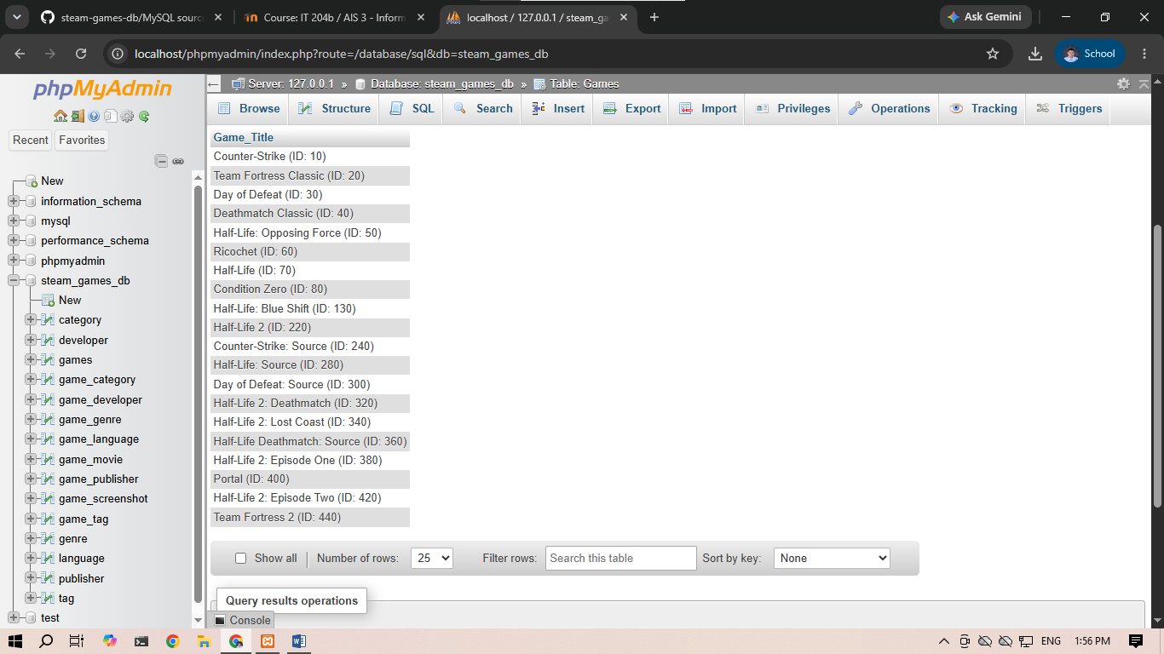
SELECT average_playtime_forever AS Total_Playtime FROM Games;
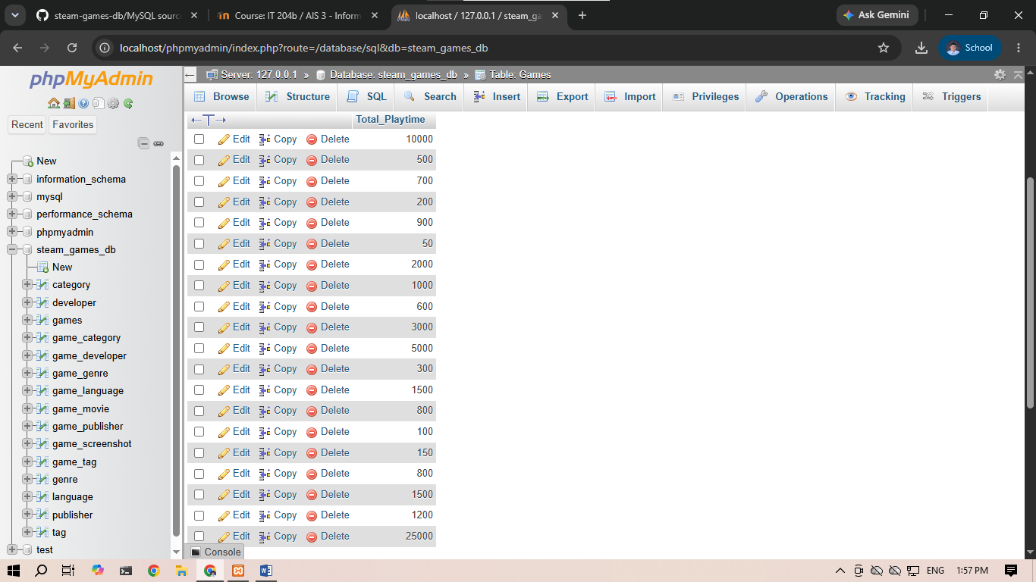

SELECT name FROM Games WHERE name LIKE 'Half-Life%';
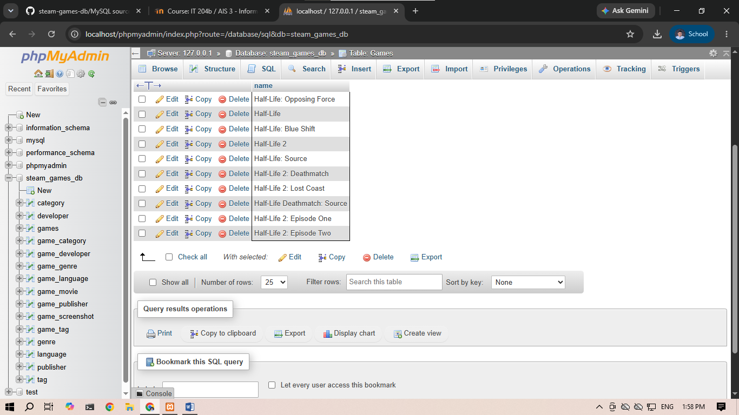
SELECT publisher_name FROM Publisher WHERE publisher_name LIKE '%Interactive';
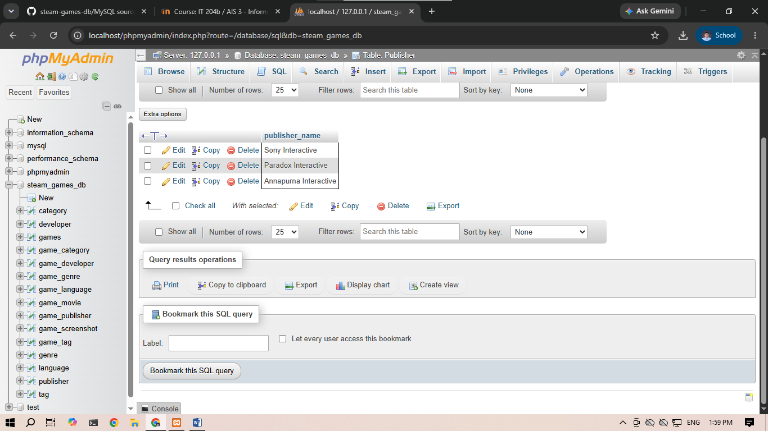

SELECT name FROM Games WHERE name LIKE 'P_rtal';
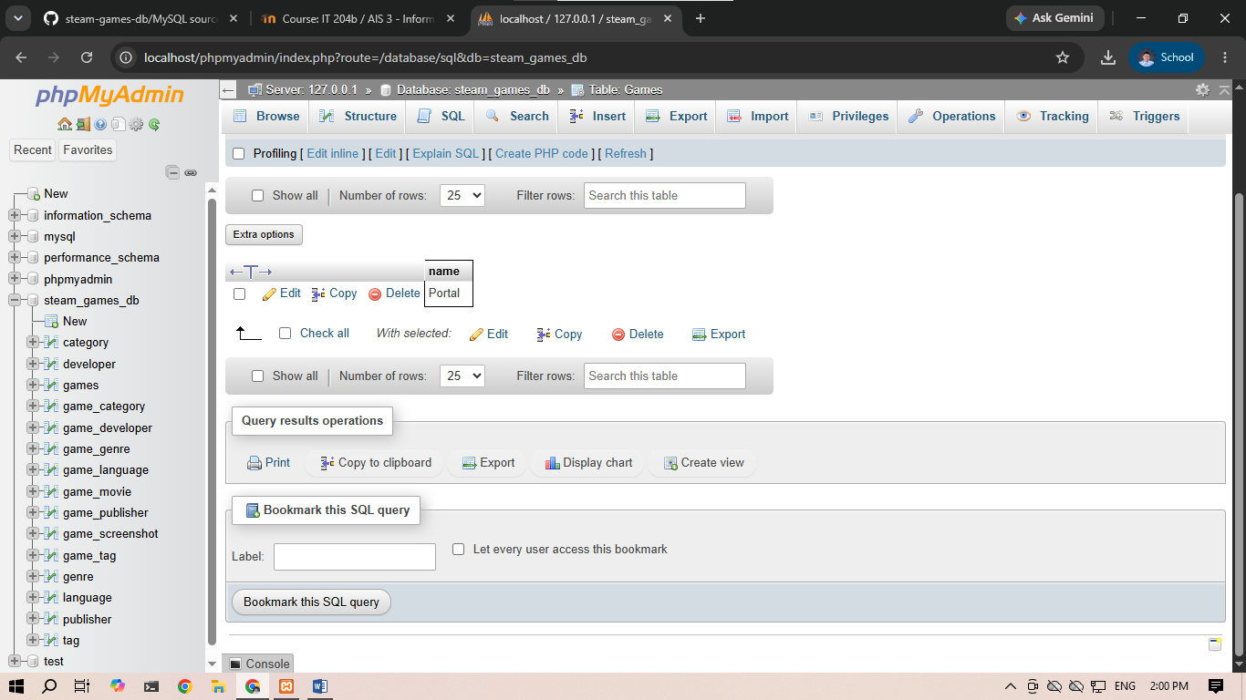
SELECT appID FROM Games WHERE appID LIKE '2_0';
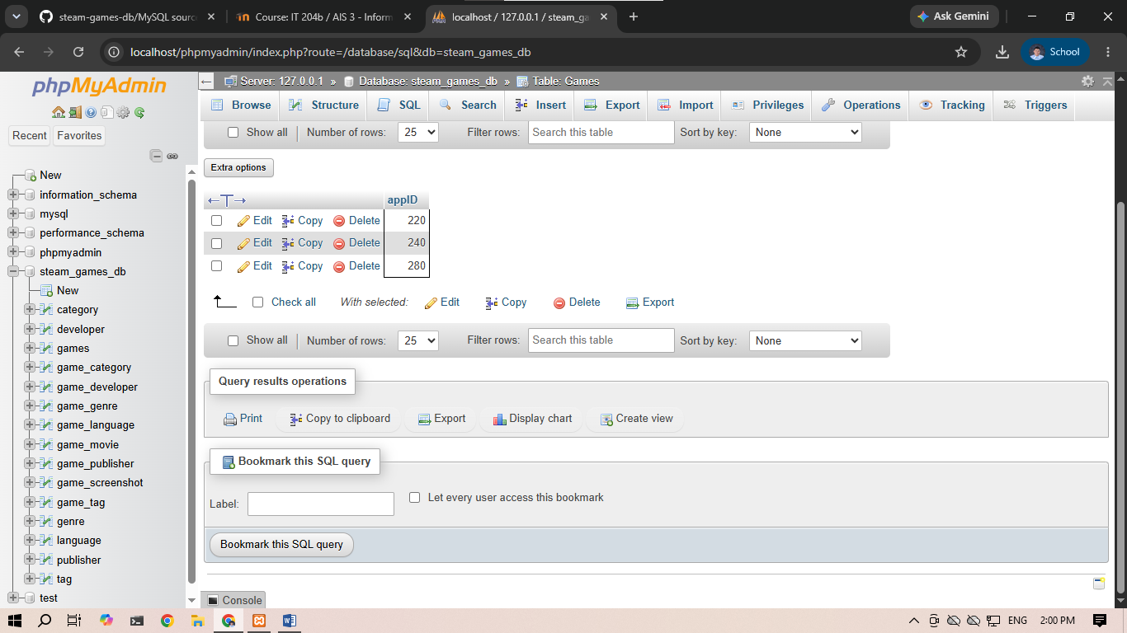

SELECT name, price FROM Games WHERE price < 10.00 AND required_age >= 13;
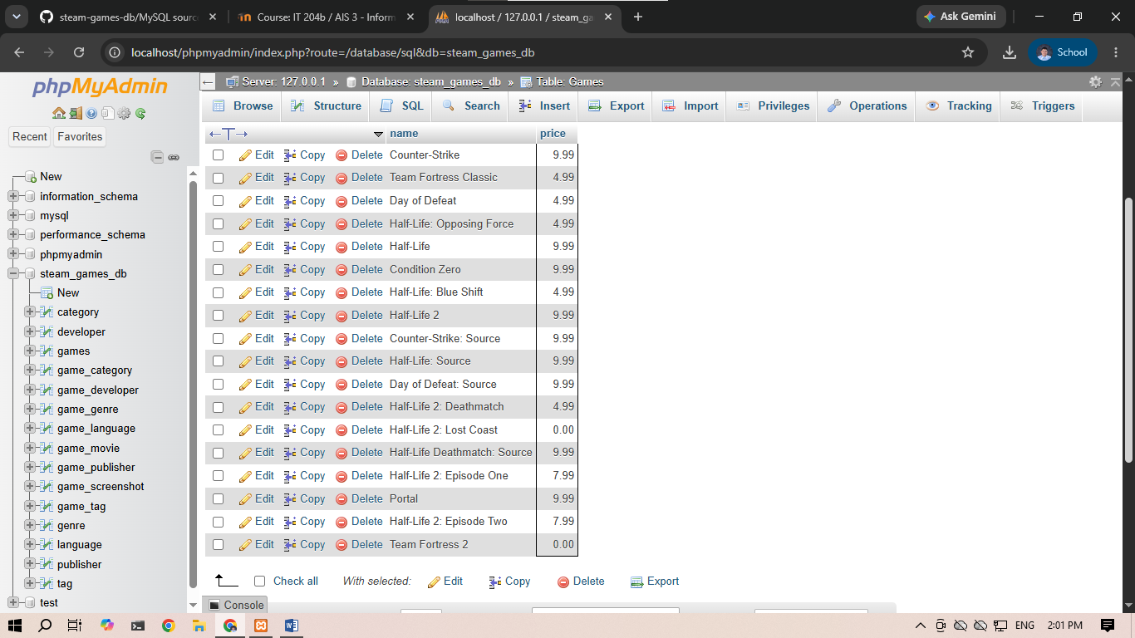
SELECT name FROM Games WHERE price = 0.00 OR price > 9.00;
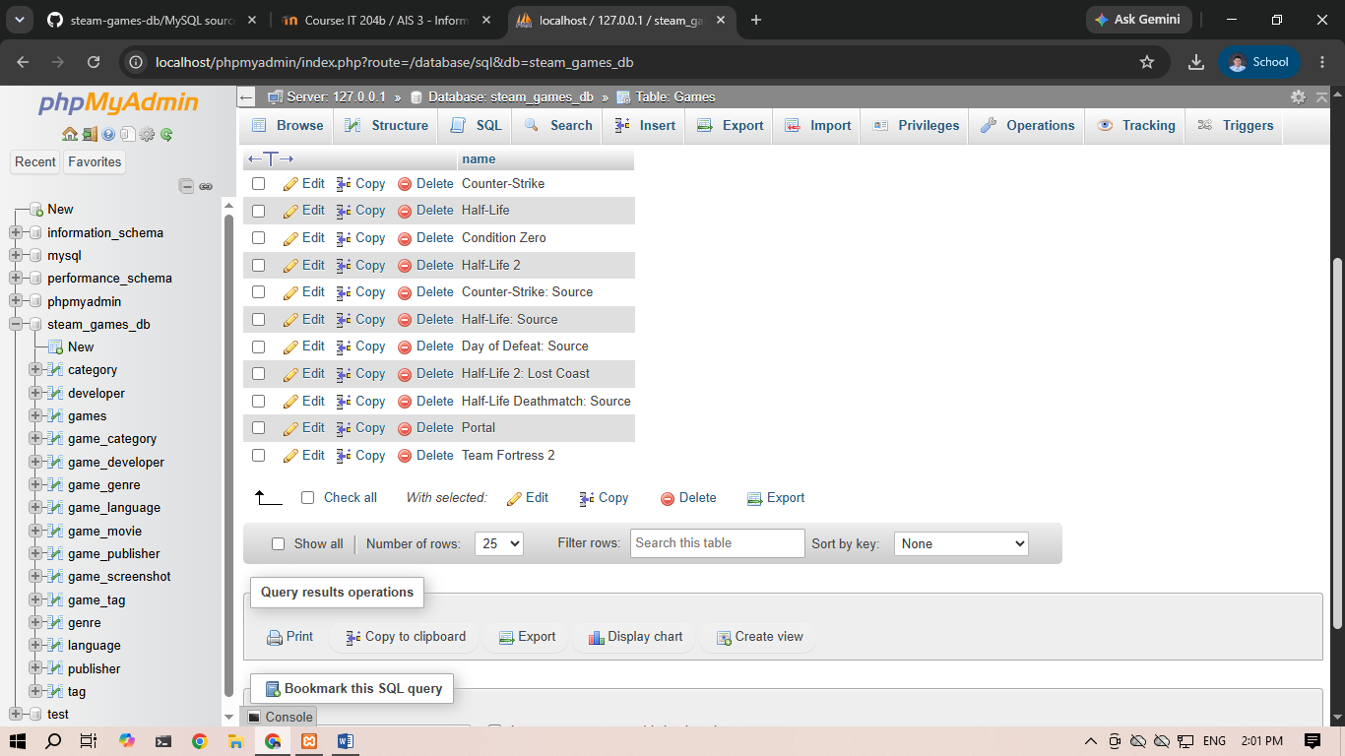

SELECT genre_name FROM Genre WHERE NOT genre_name = 'Action';
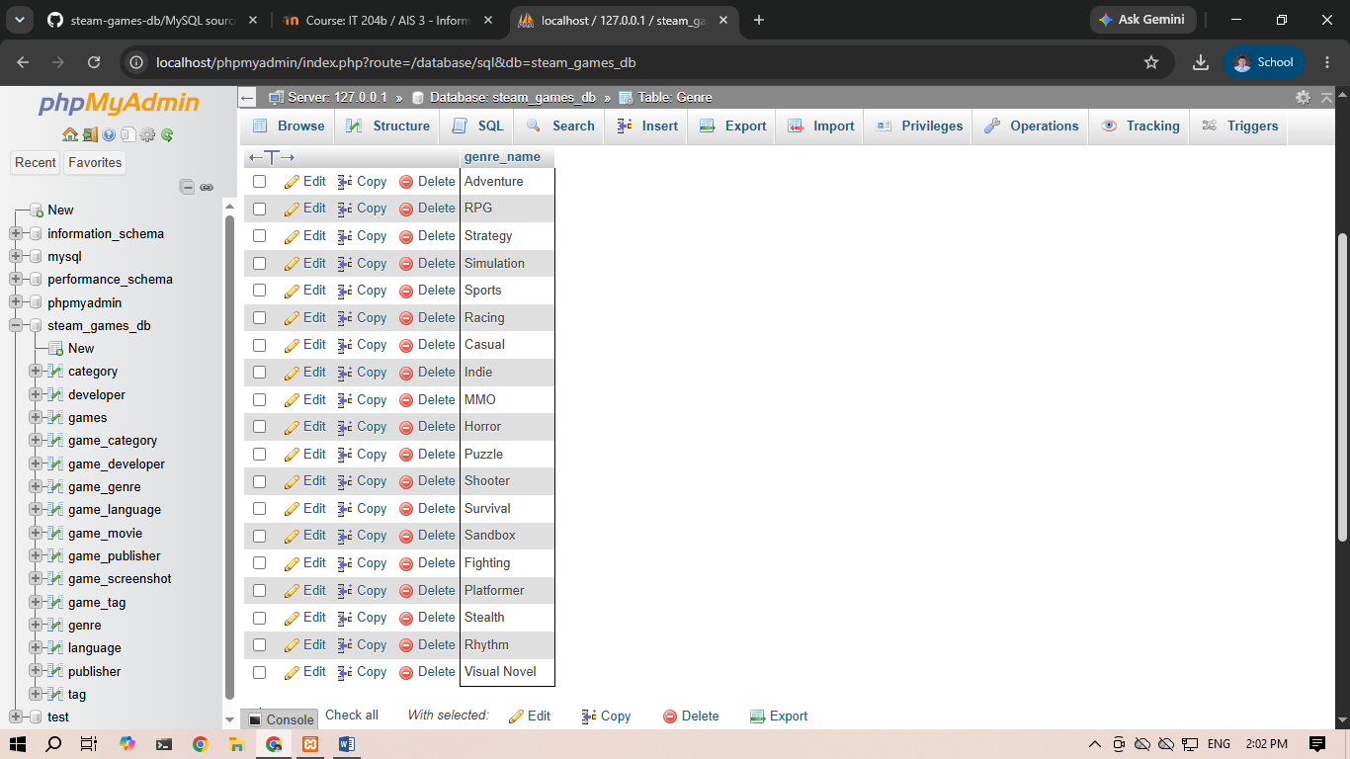
SELECT name, release_date FROM Games ORDER BY release_date DESC;
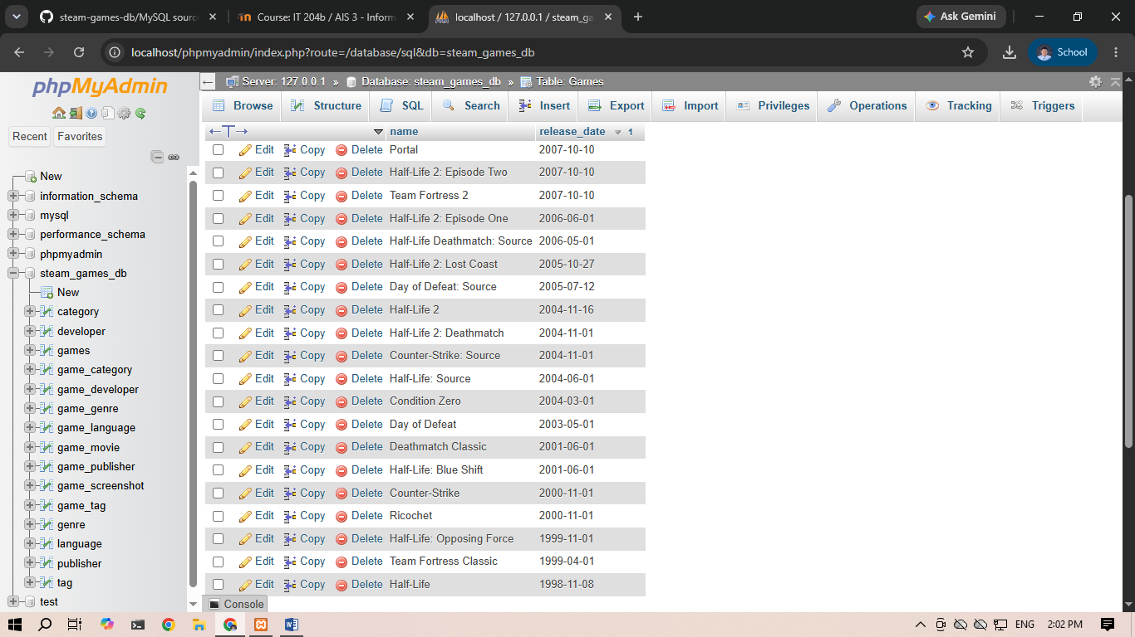

SELECT publisher_name FROM Publisher ORDER BY publisher_name ASC;
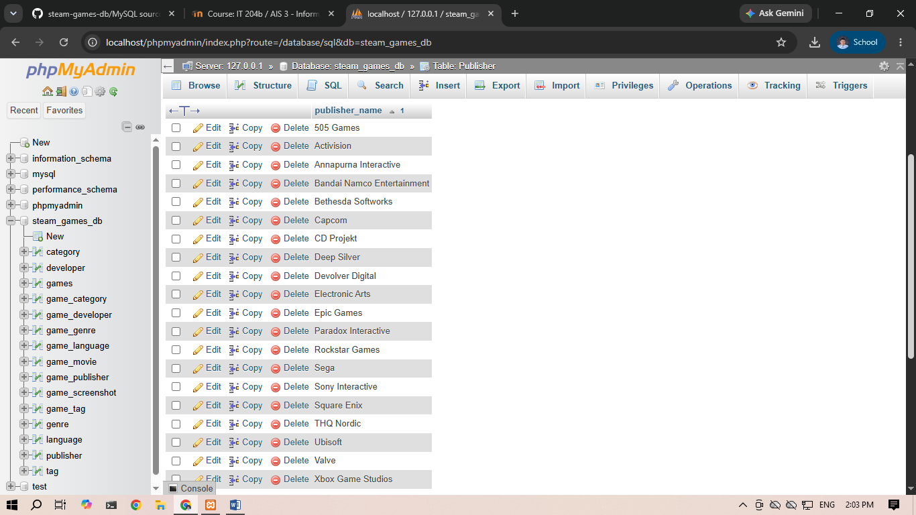
SELECT name FROM Games ORDER BY price DESC LIMIT 5;
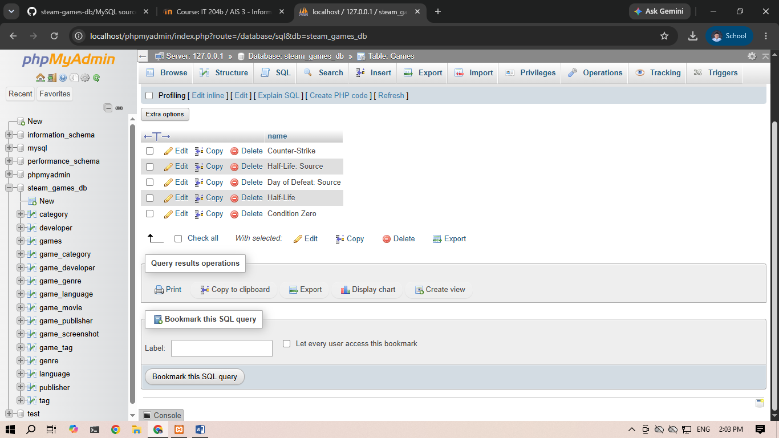

SELECT MIN(price) AS lowest_price FROM Games;
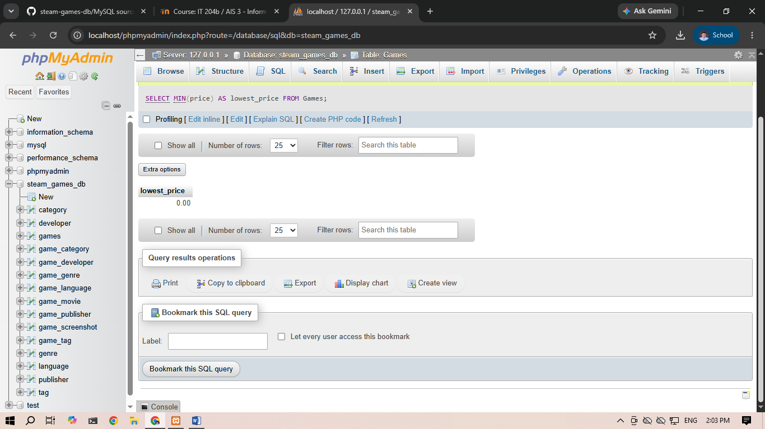
SELECT MAX(peak_ccu) AS highest_peak_players FROM Games;
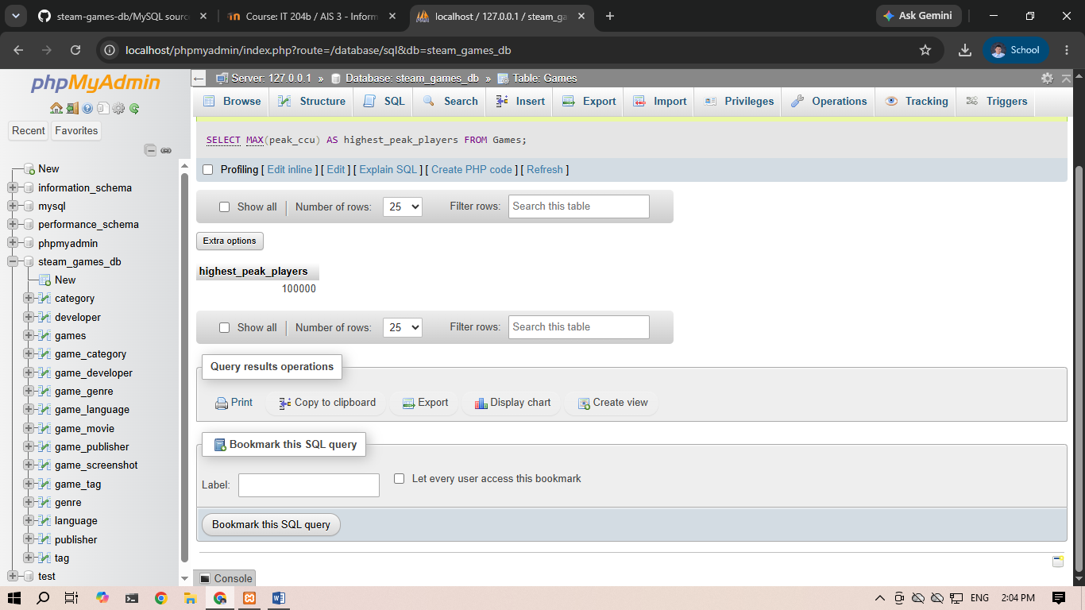

SELECT SUM(positive) AS total_positive_feedback FROM Games;
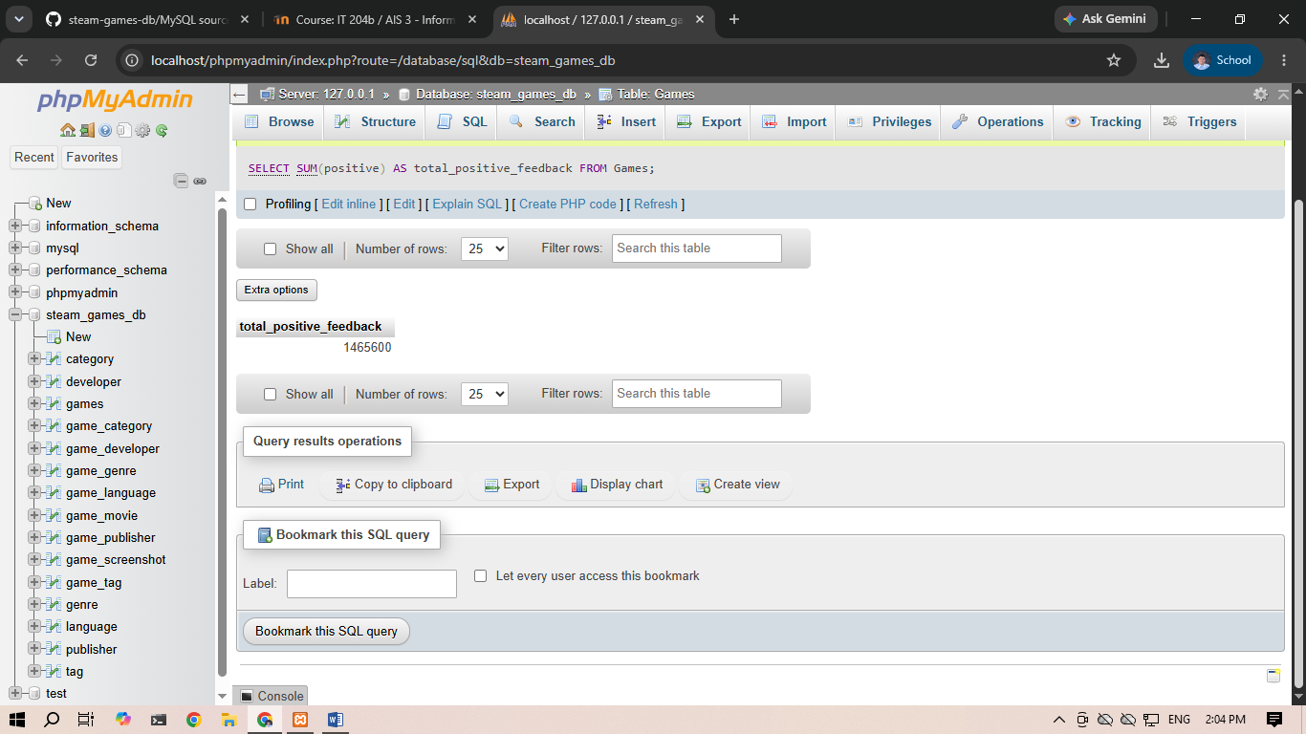
SELECT AVG(metacritic_score) AS average_metacritic FROM Games WHERE metacritic_score IS NOT NULL;
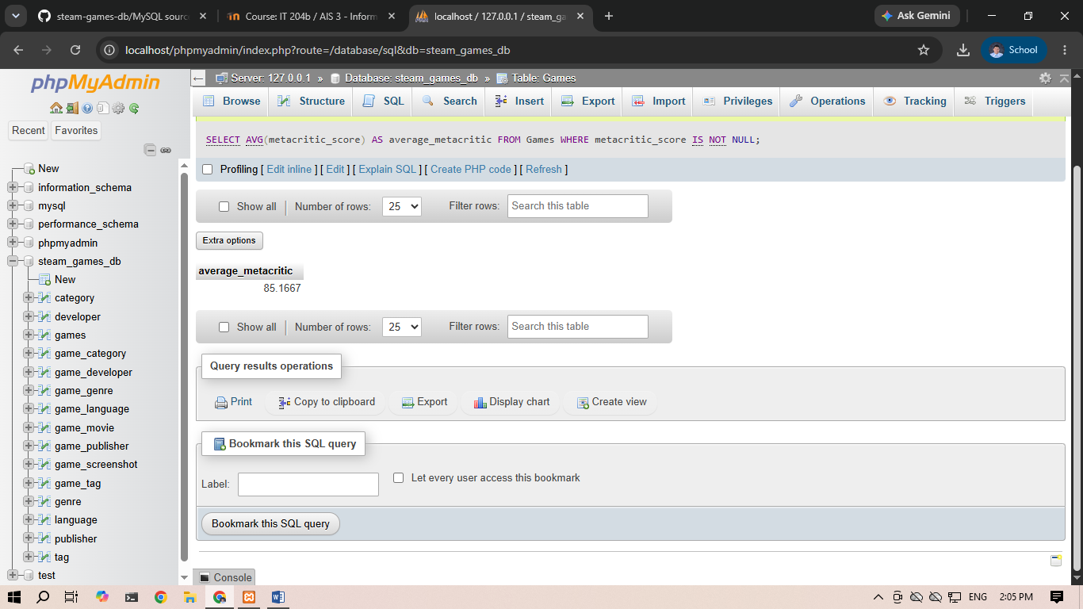

SELECT COUNT(*) AS total_games_listed FROM Games;
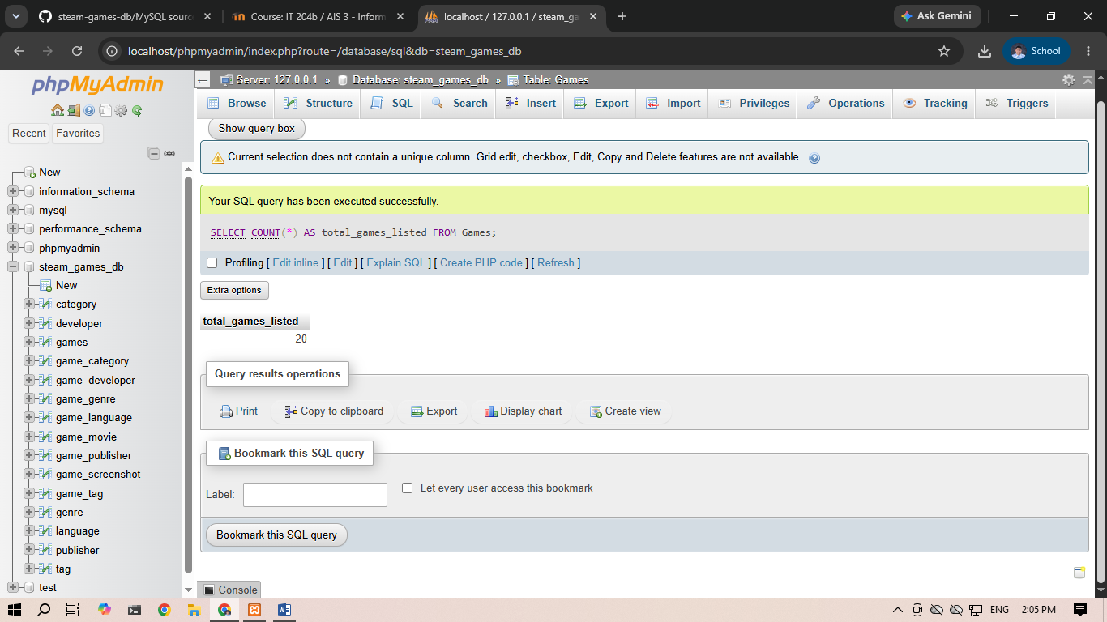
SELECT required_age, COUNT(*) AS game_count FROM Games GROUP BY required_age;
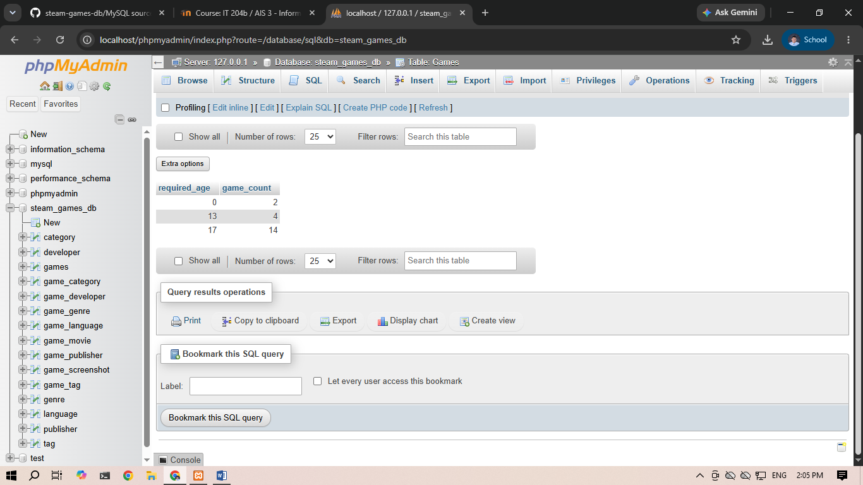

SELECT estimated_owners, AVG(peak_ccu) AS avg_ccu FROM Games GROUP BY estimated_owners;
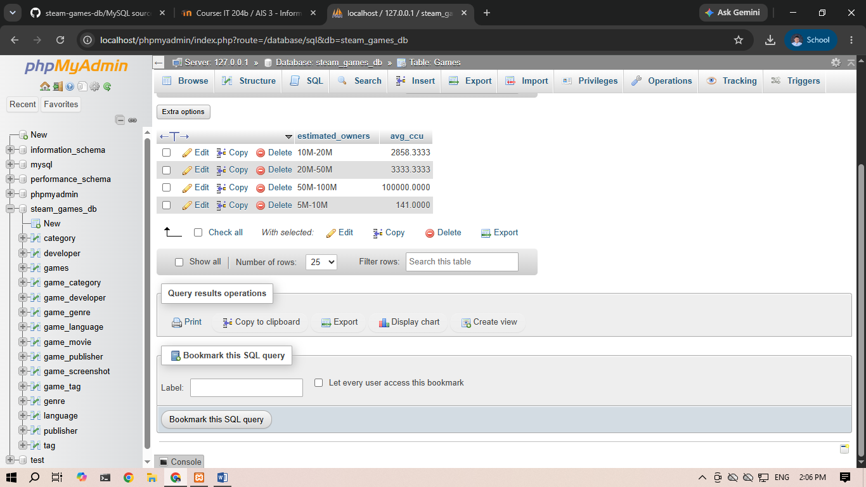
SELECT required_age, COUNT(*) AS game_count FROM Games GROUP BY required_age HAVING COUNT(*) > 5;
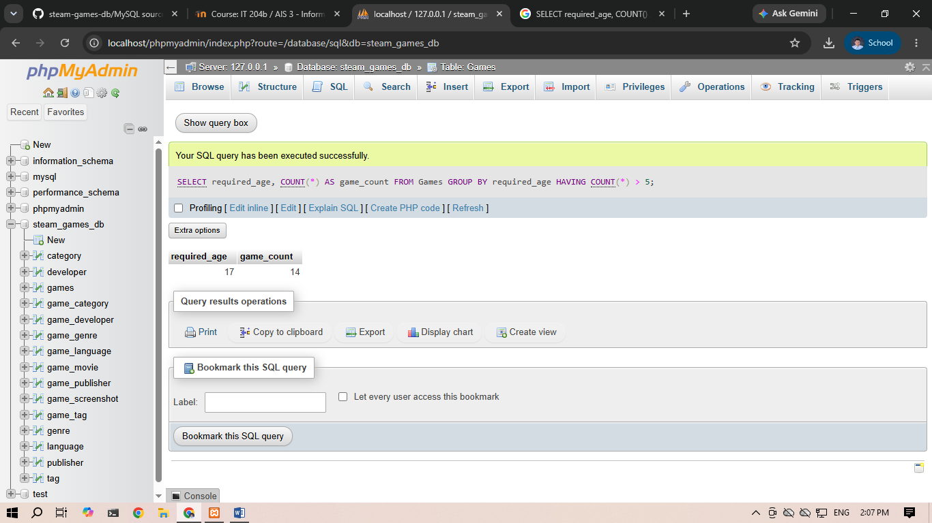

SELECT estimated_owners, SUM(positive) AS total_pos FROM Games GROUP BY estimated_owners HAVING SUM(positive) > 50000;
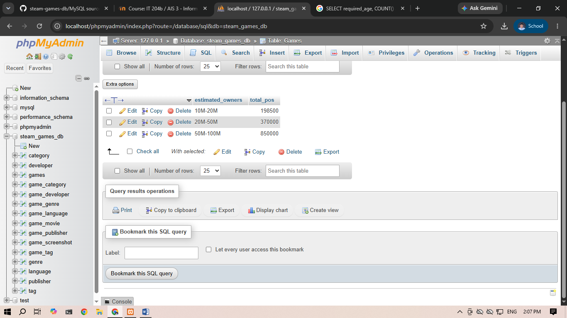
SELECT name FROM Games WHERE appID IN (10, 70, 220, 400);
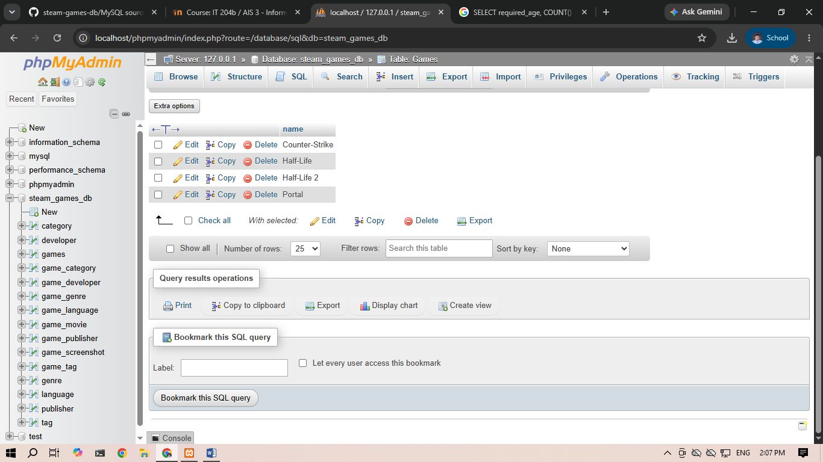

SELECT name, release_date FROM Games WHERE release_date BETWEEN '2000-01-01' AND '2005-12-31';
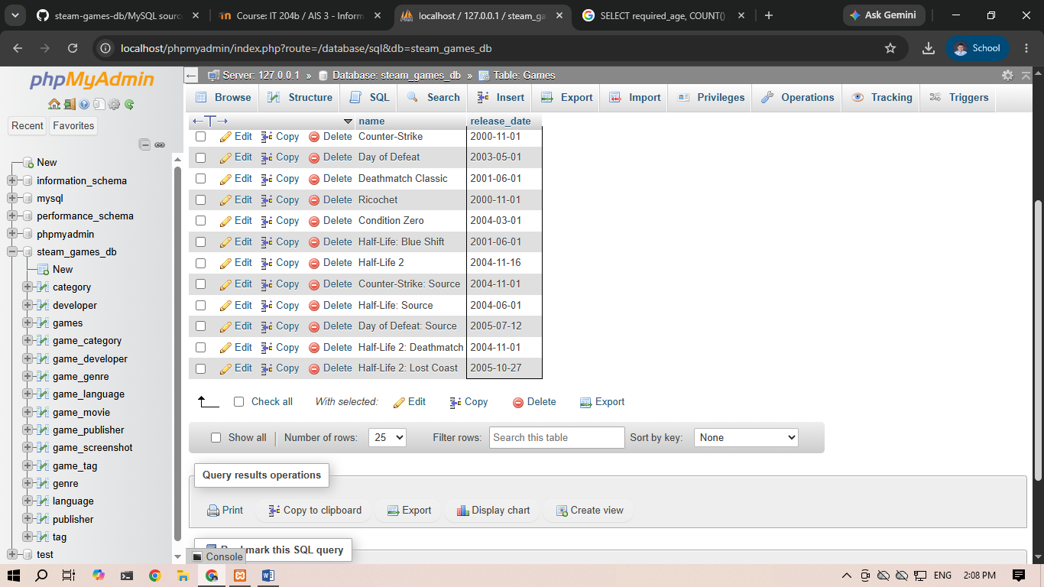
SELECT G.name, D.developer_name
FROM Games G
INNER JOIN Game_Developer GD ON G.appID = GD.appID
INNER JOIN Developer D ON GD.developer_id = D.developer_id;
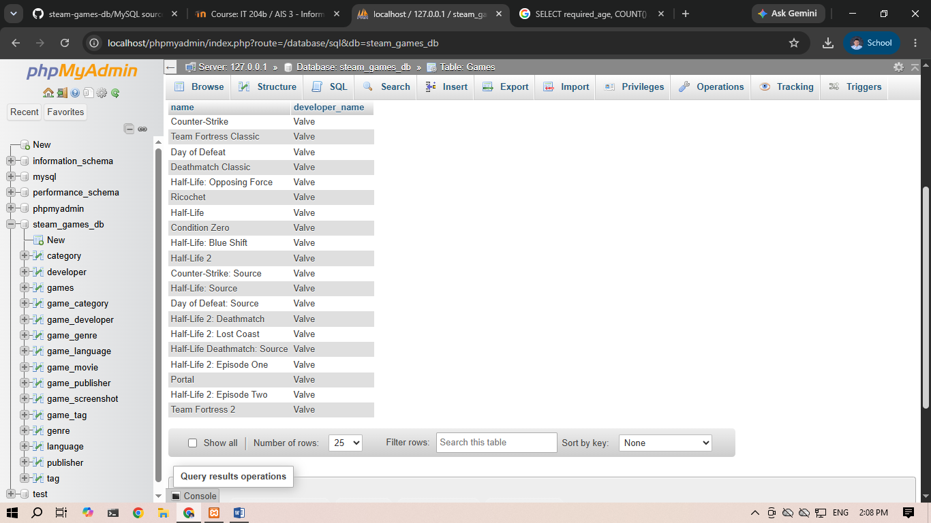

SELECT G.name, P.publisher_name
FROM Games G
INNER JOIN Game_Publisher GP ON G.appID = GP.appID
INNER JOIN Publisher P ON GP.publisher_id = P.publisher_id;
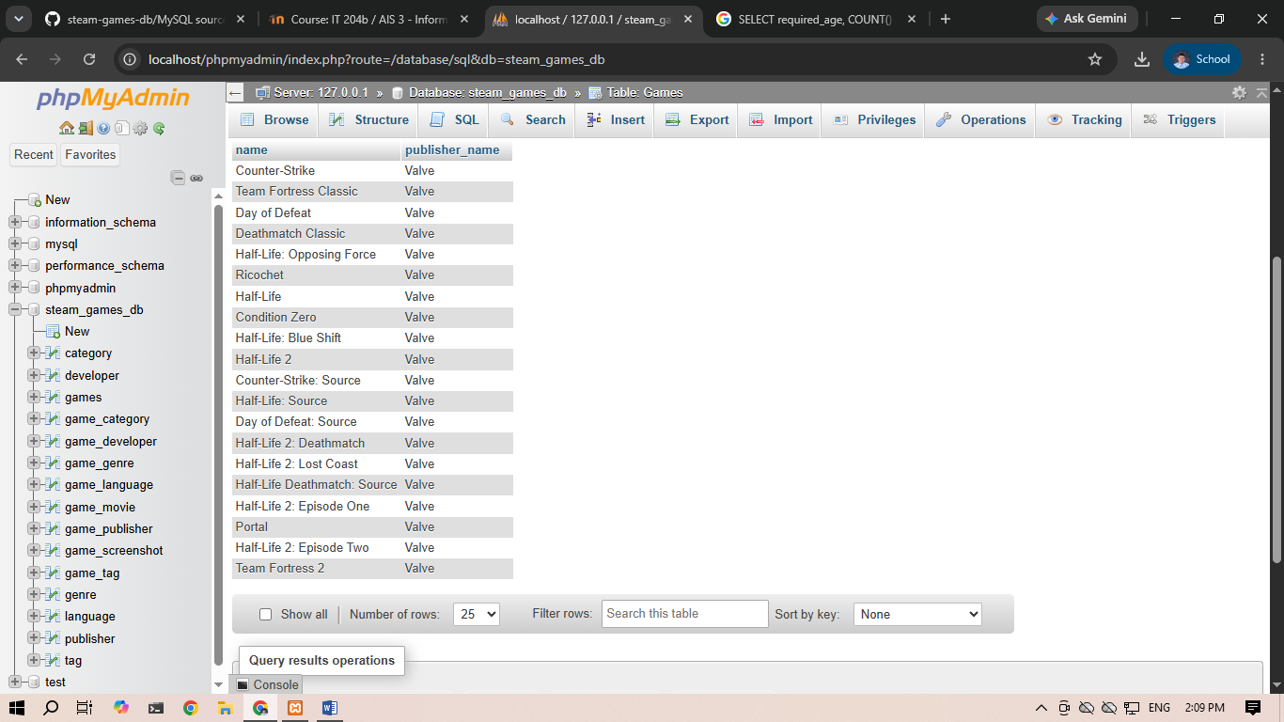

SELECT G.name, G.positive, G.negative
FROM Games G
WHERE G.positive / (G.positive + G.negative) > 0.90;
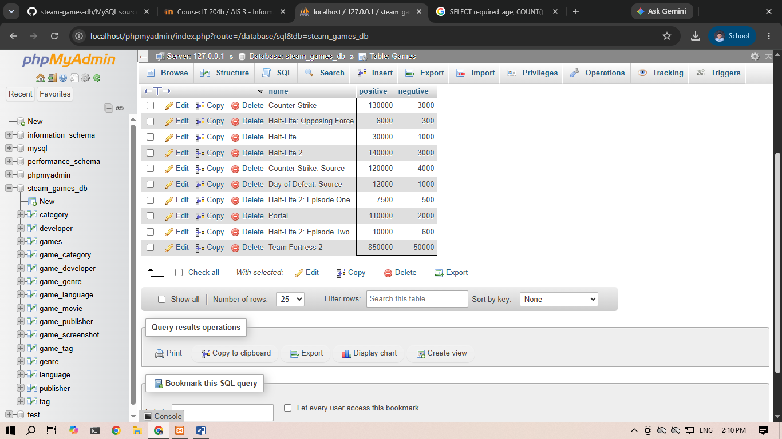

SELECT G.name, G.peak_ccu
FROM Games G
WHERE G.price = 0.00
ORDER BY G.peak_ccu DESC;
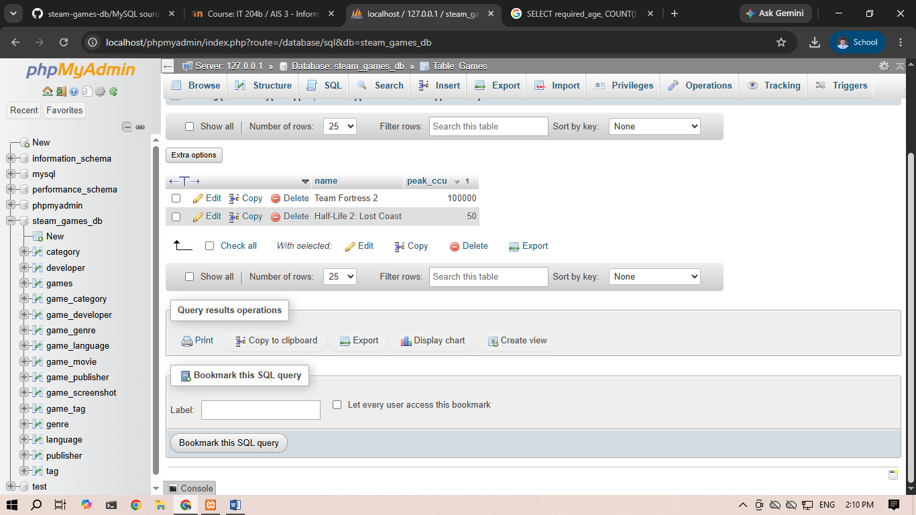

SELECT G.name, C.category_name
FROM Games G
JOIN Game_Category GC ON G.appID = GC.appID
JOIN Category C ON GC.category_id = C.category_id
WHERE G.appID = 10;
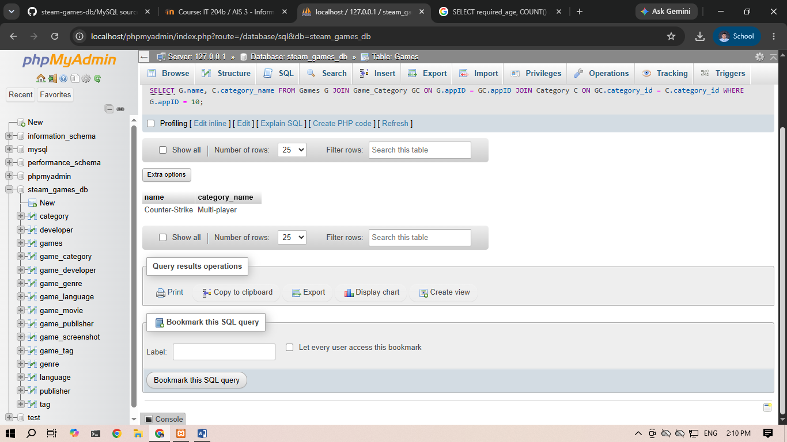

SELECT G.name,D.developer_name,G.support_email FROM Games G JOIN Game_Developer GD ON G.appID = GD.appID JOIN Developer D ON GD.developer_id = D.developer_id WHERE G.required_age >= 17 GROUP BY G.name,D.developer_name,G.support_email;
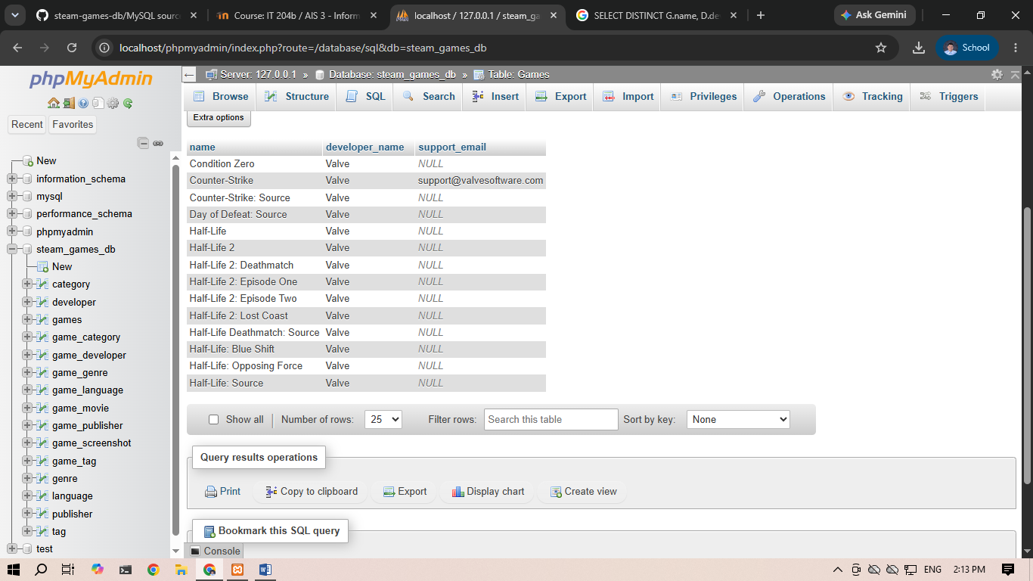

SELECT G.name, (G.positive + G.negative) * G.average_playtime_forever AS engagement_score
FROM Games G
ORDER BY engagement_score DESC LIMIT 10;
